**User Management**

**Collex**

Please follow the below mentioned steps to create user and assign different roles.

* Any **User** signing up from **Create new account** link will be assigned **Admin** role **by the system**. 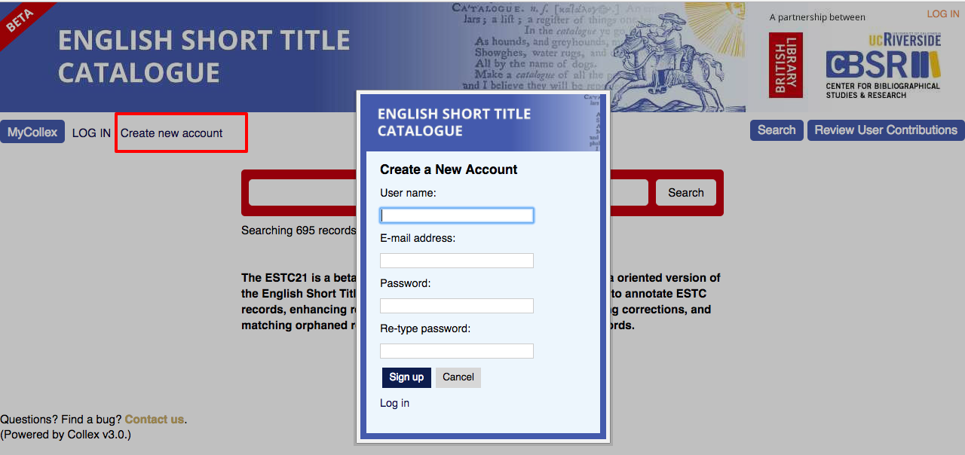
* Enter **username**, **email address** (for **password recovery**) and **password**. 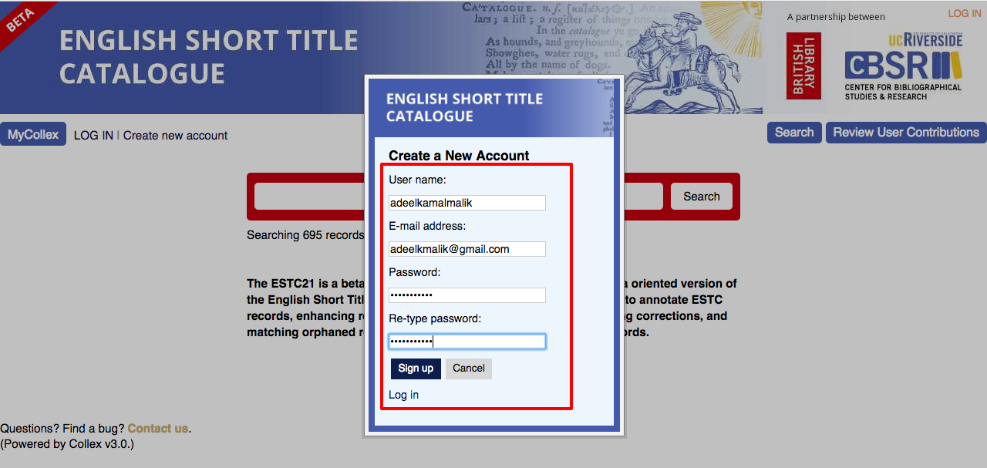
* Click **Signup** button, this will redirect you to the **Admin Dashboard**. 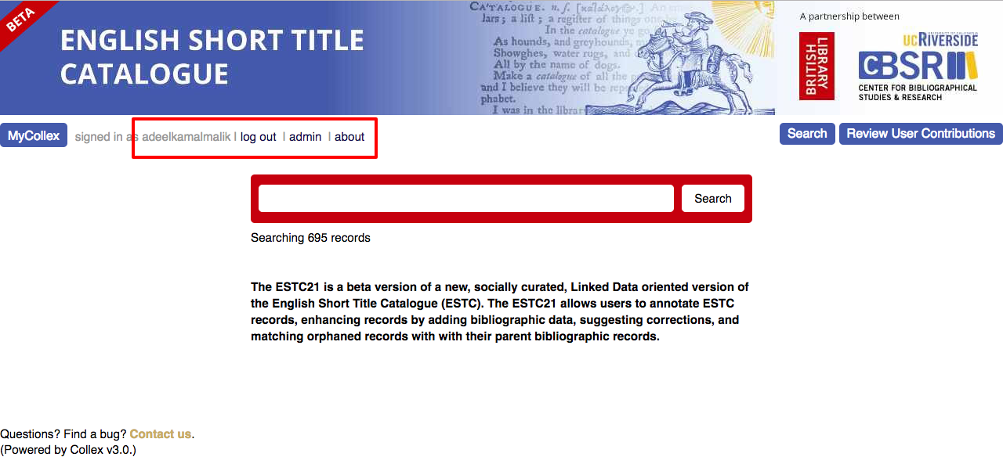
* Now click on **admin** link, you’ll see another screen with **Admin related** features’menu**.** 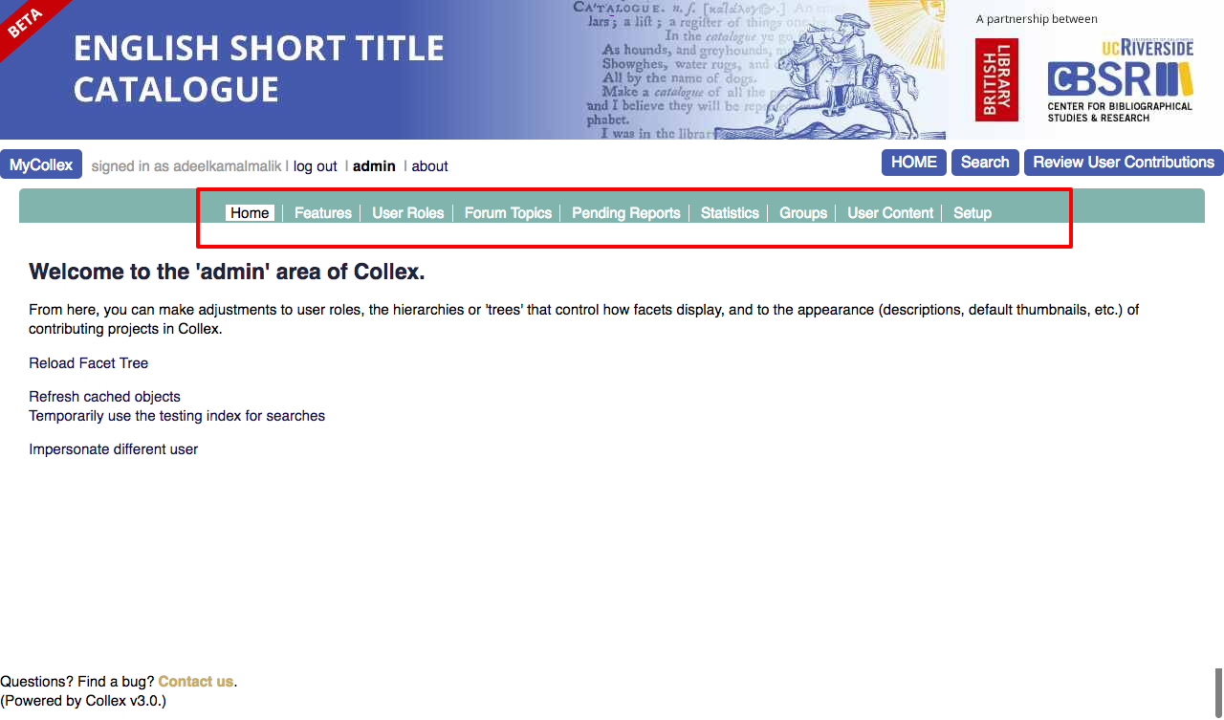
* Click on **User Roles** and user will be redirected to the **users listing.** 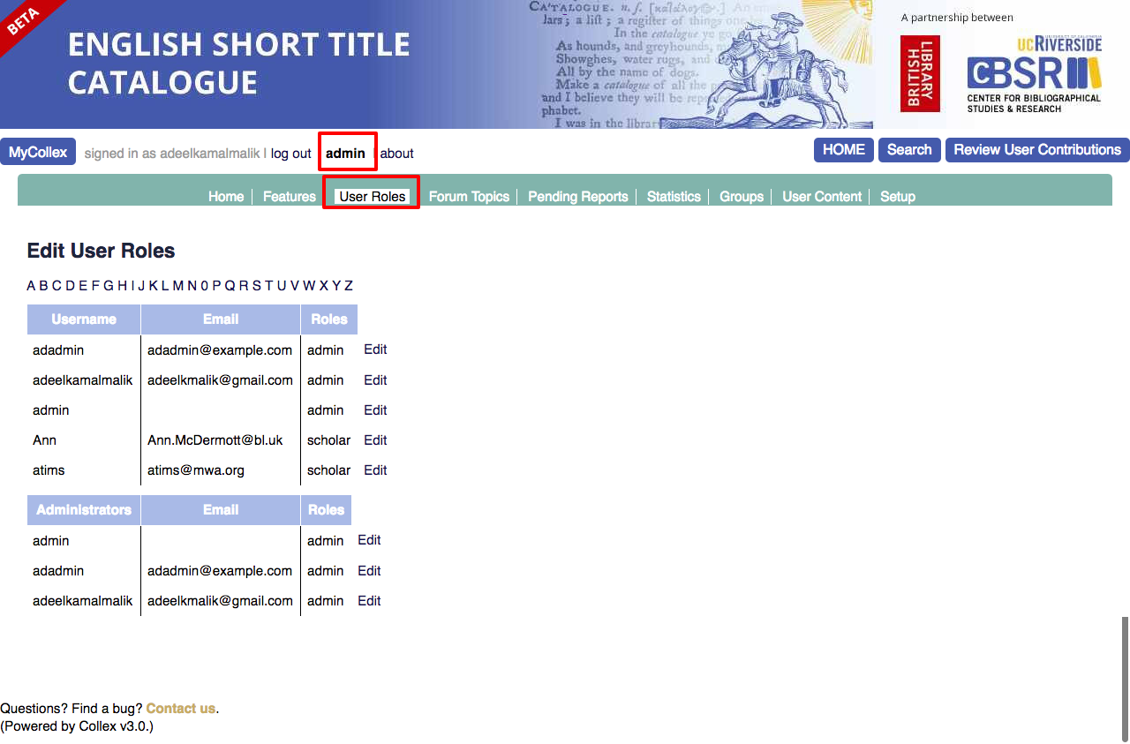
* All users are listed including **admins**. 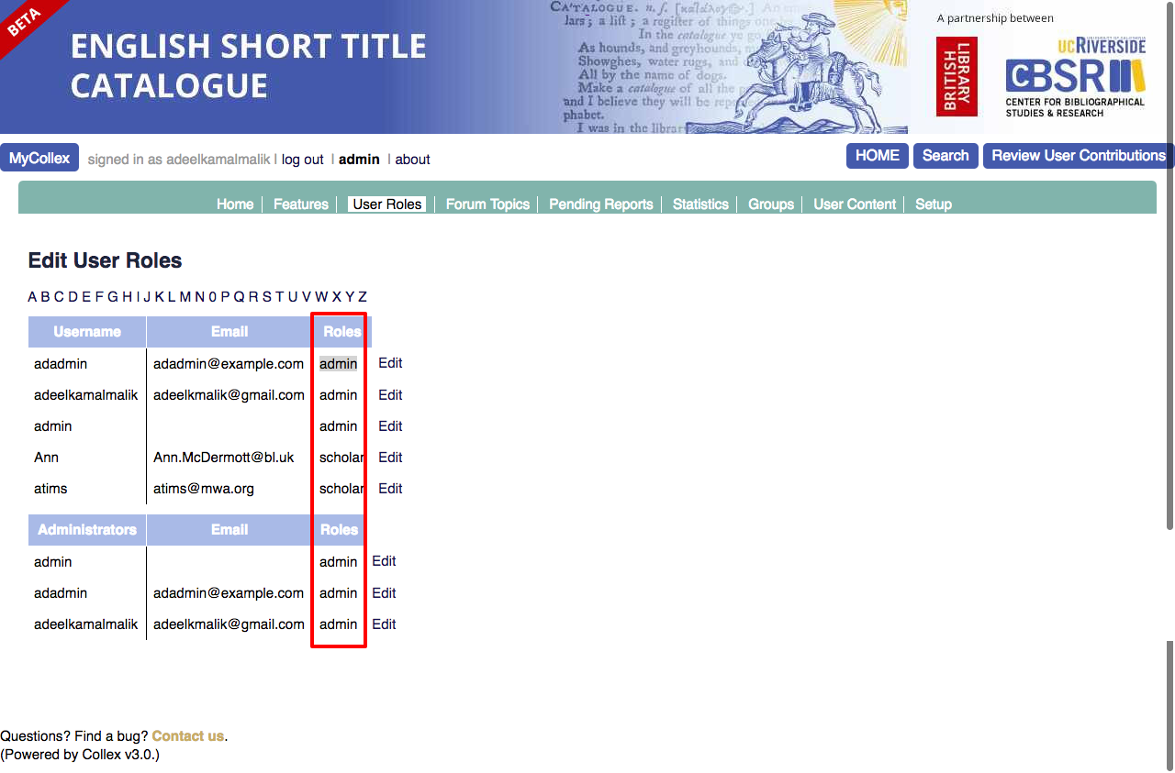
* To **change role of any user** click **edit** link. User will see another screen with all fields populated. 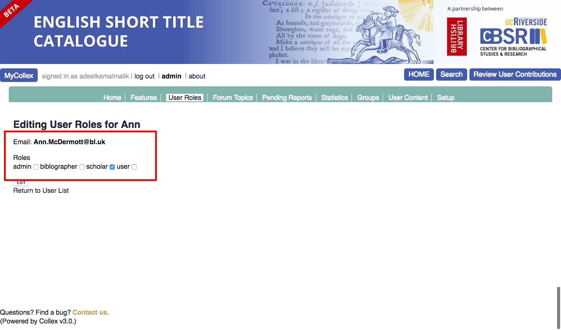
* Change user role and click **edit** button to update changes in the system.
* User can **filter** **list** by clicking on the **alphabet** over the user listing. 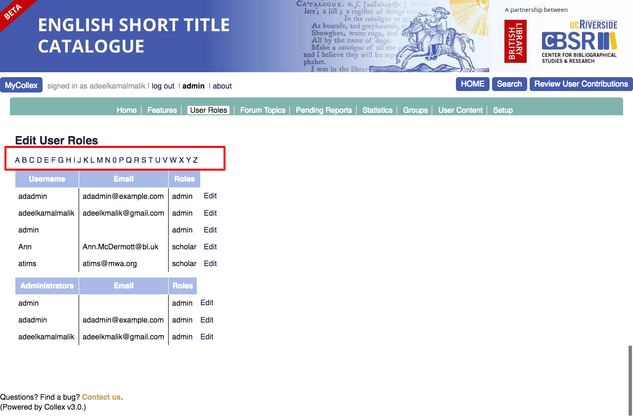

**Impersonate as another User:**

* Click **Home** in admin menu. 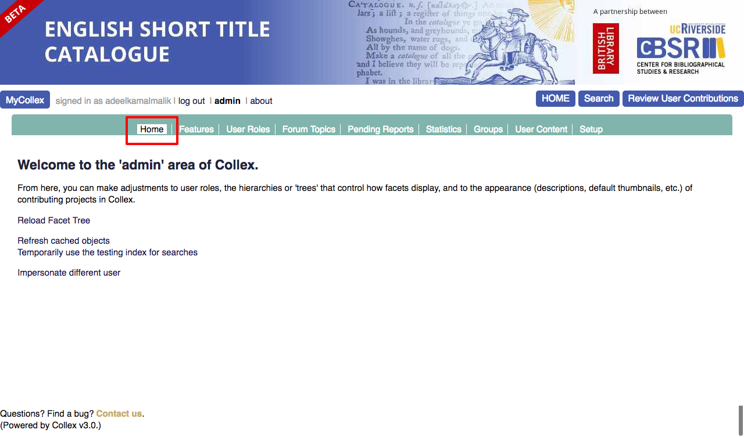
* Click on **Impersonate different user** link, user will be able to see a **popup** with **users drop-down** as shown in the screenshot below**.**   
  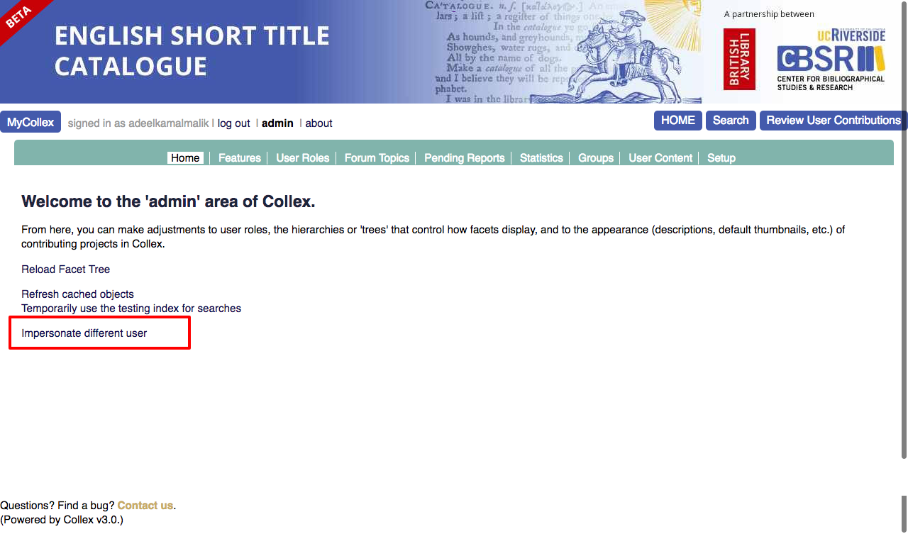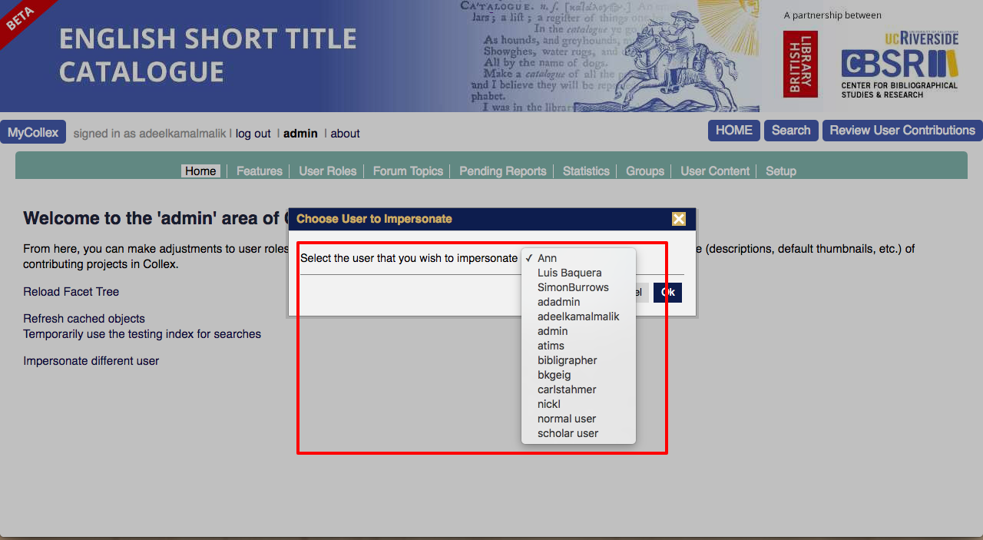
* **Select any user** and click **Ok**, user will be **logged in as that selected user** with all relevant permissions. 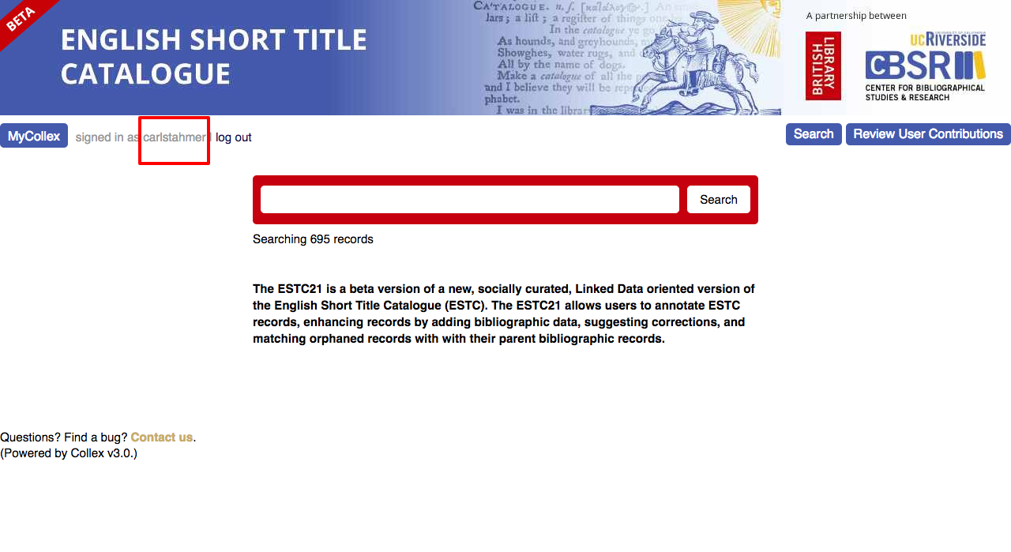

**Catalog**

* User are being created from the backend **RAKE TASK** running from **Terminal using** following command:
  + Move to project directory
  + Bundle install
  + *Run* ***rake users:create user=[email], [password]***
  + For instance, **rake users:create user=akmtest@gmail.com, akmtest123** 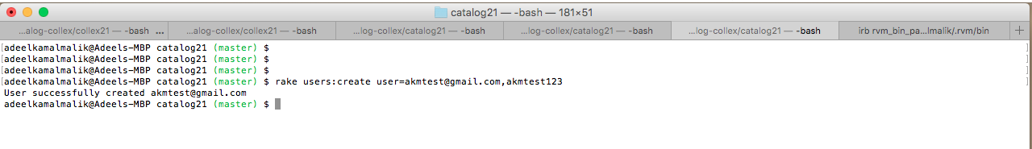
* Hit URL: <http://estc21.ucr.edu:3000/> in the browser, user will be able to see **Catalog’s landing page.** Click **Admin** link present at the bottom of this page as shown in this screenshot. 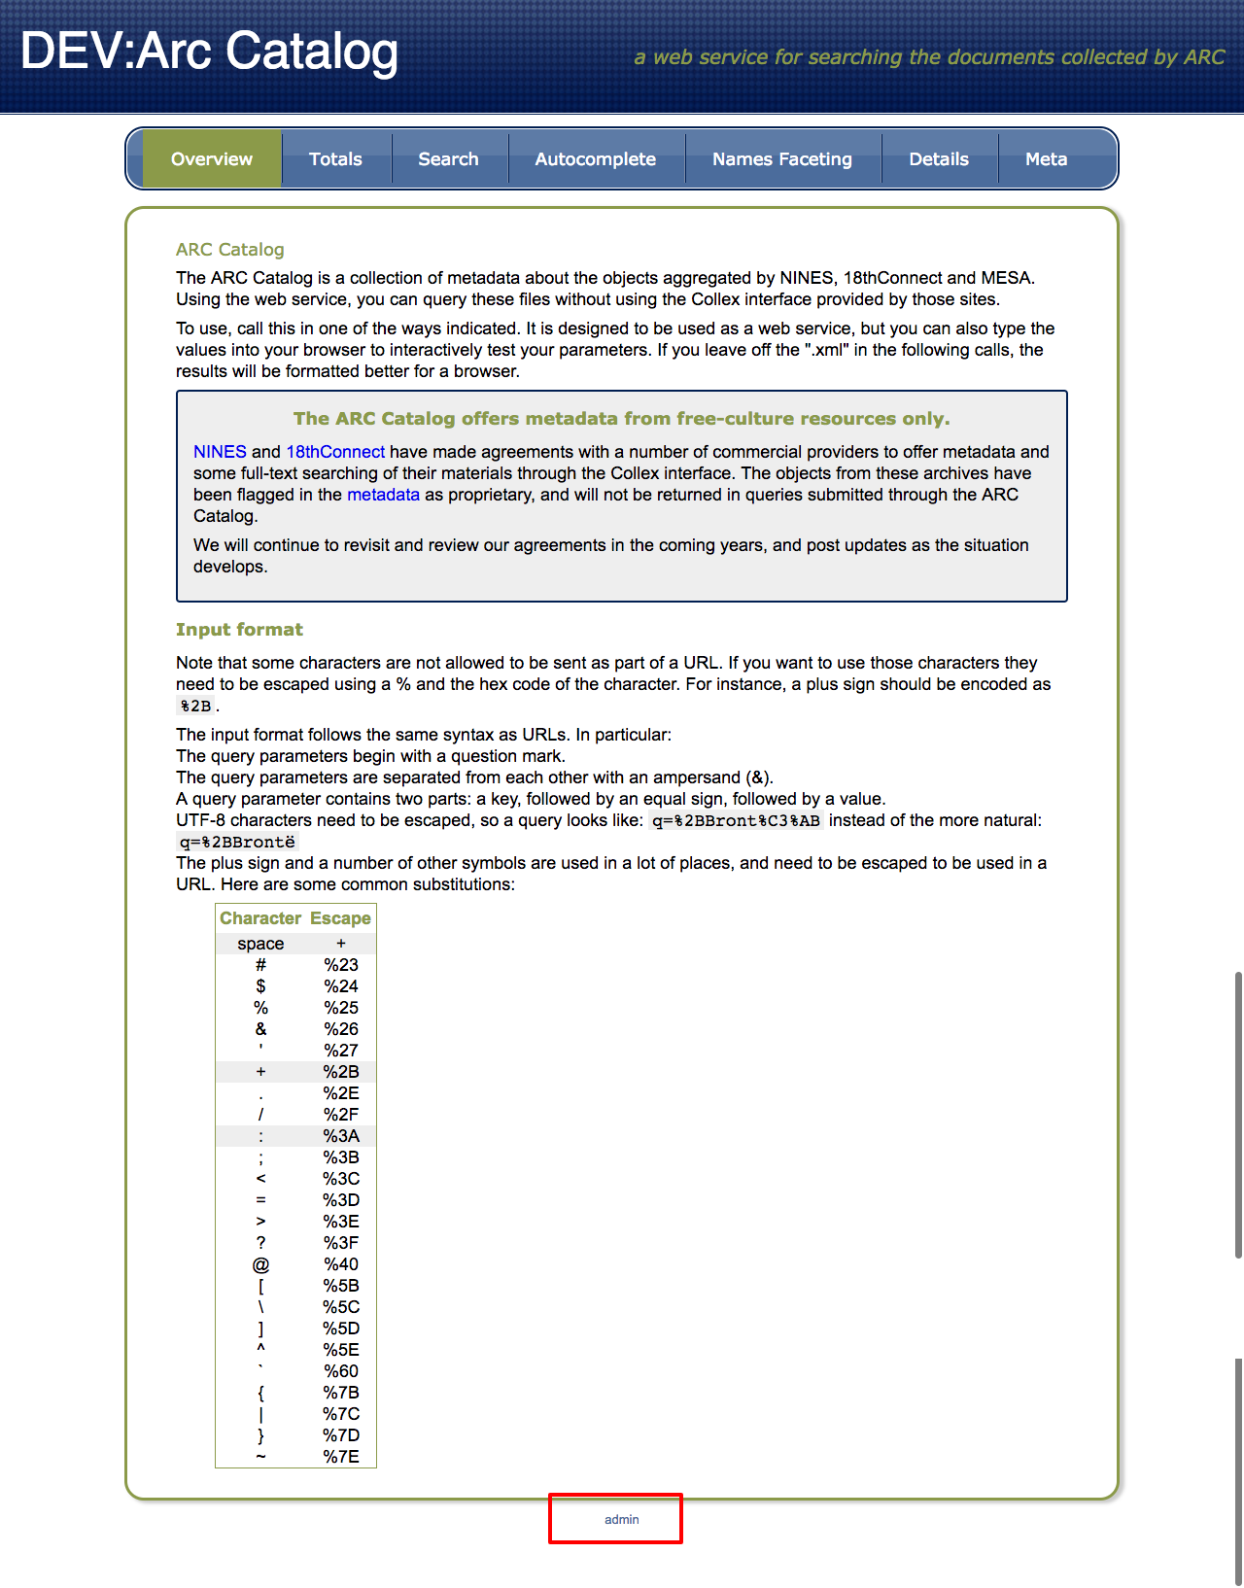
* User will be redirected to the **Login** page. Enter **Email** and **Password,** click **Sign In.** 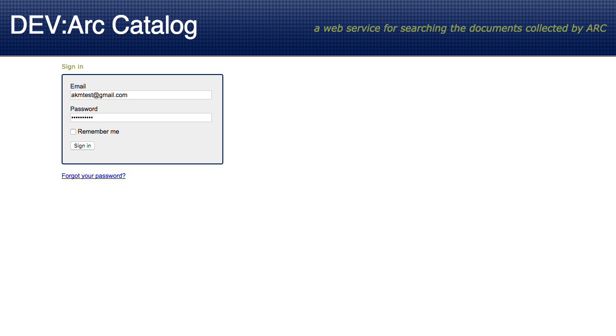
* **User** will be able to see a ***sign in successfully*** notification while on dashboard. At the bottom, there are a couples of features that user can manage. e.g; *manage genres, manage disciplines, and manage archives etc* as shown below: 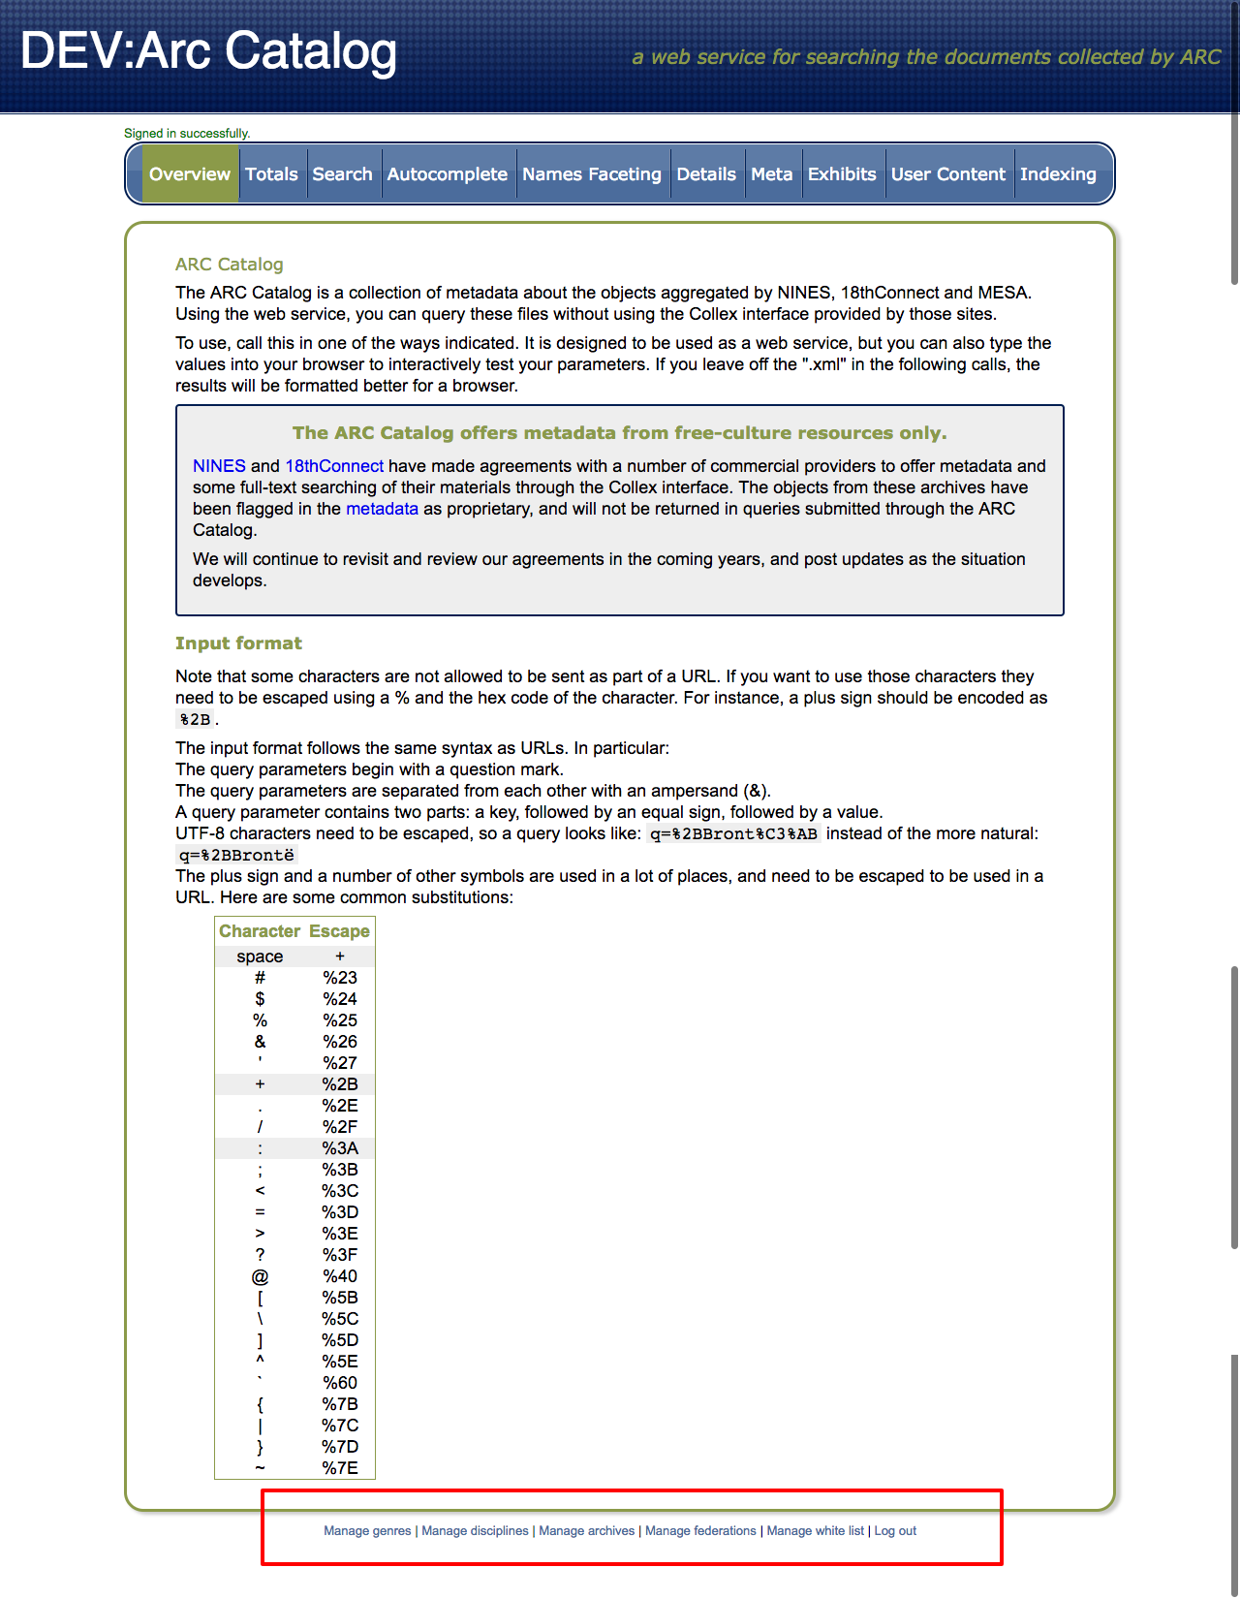
* **Manage Genres**: User will be able to **manage (Create / Update / Delete) genres** by clicking link at that bottom. 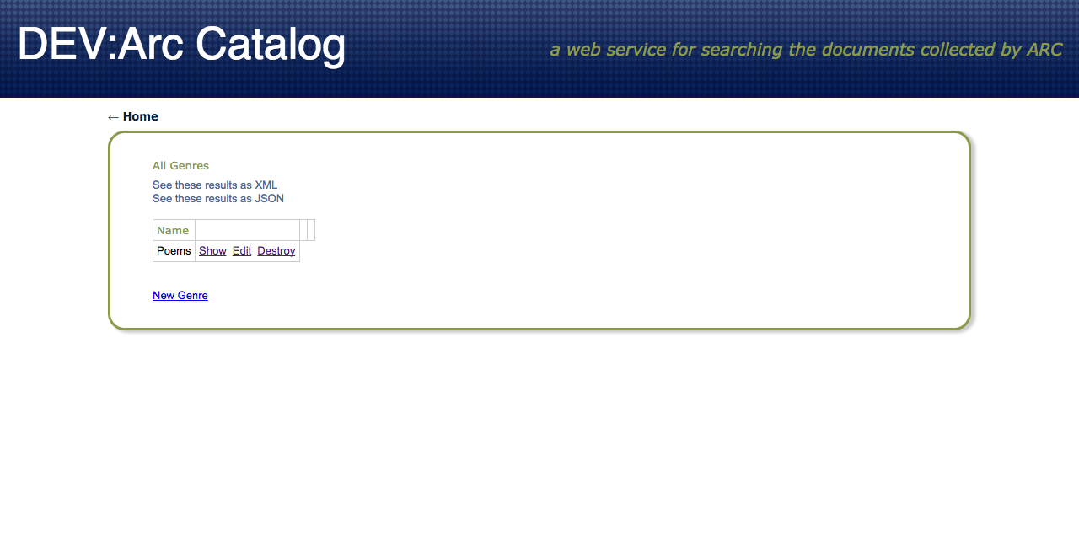
* **Manage Disciplines**: User will be able to **manage (Create / Update / Delete) disciplines** by clicking link at that bottom. 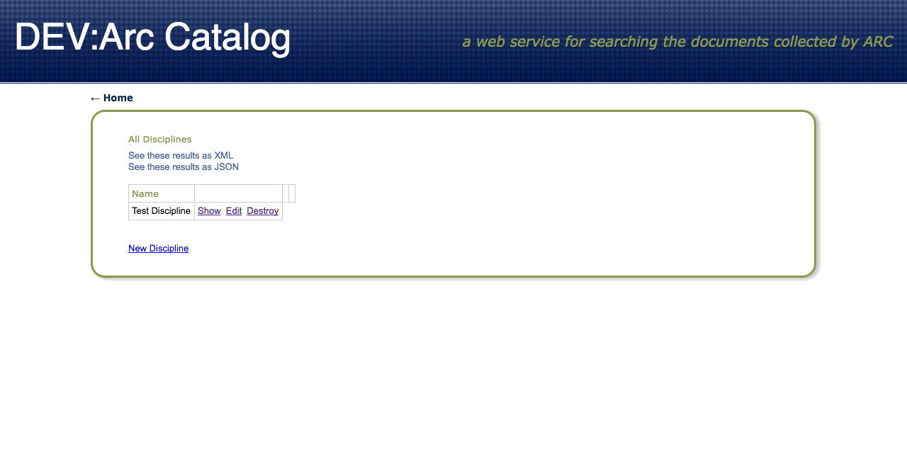
* **Manage Archives**: User will be able to **manage (Create / Update / Delete) archives** by clicking link at that bottom. 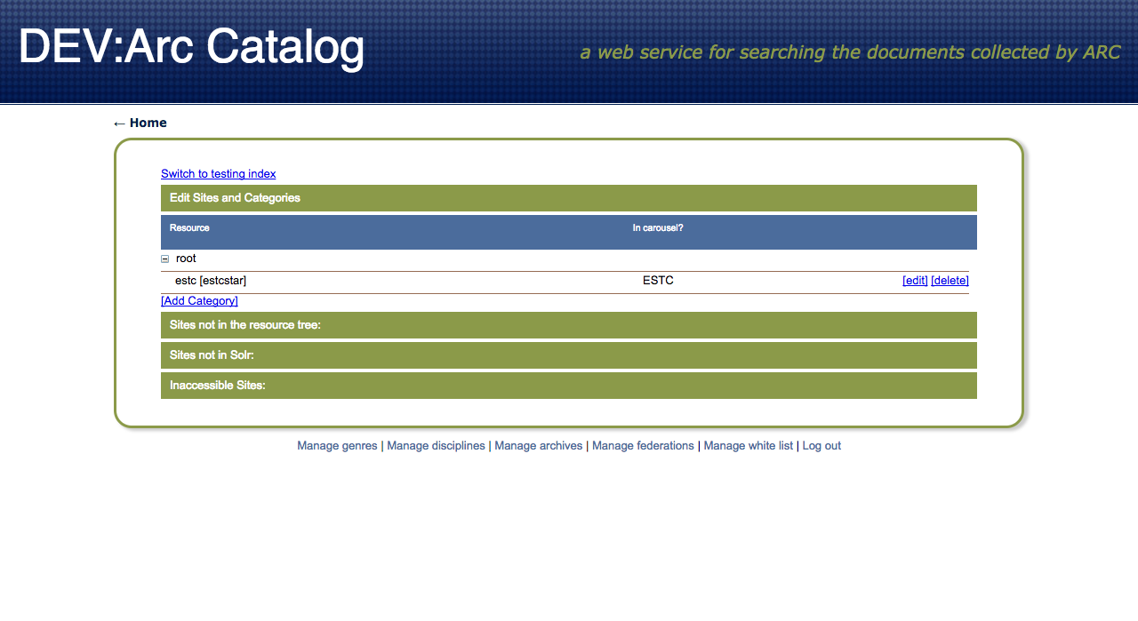
* **Manage Federations**: User will be able to **manage (Create / Update / Delete) federations** by clicking link at that bottom. 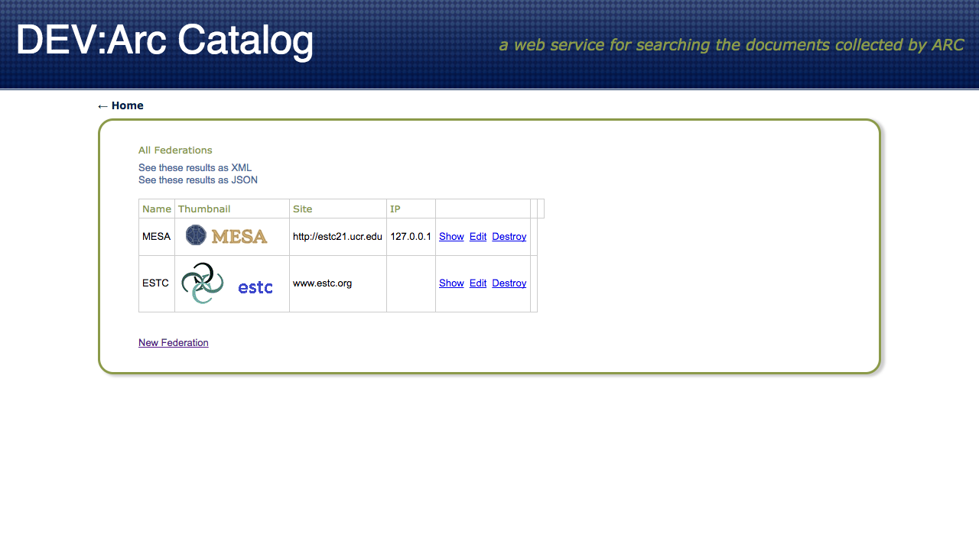
* **Manage Whitelist**: User will be able to **manage (Create / Update / Delete) whitelist** by clicking link at that bottom. 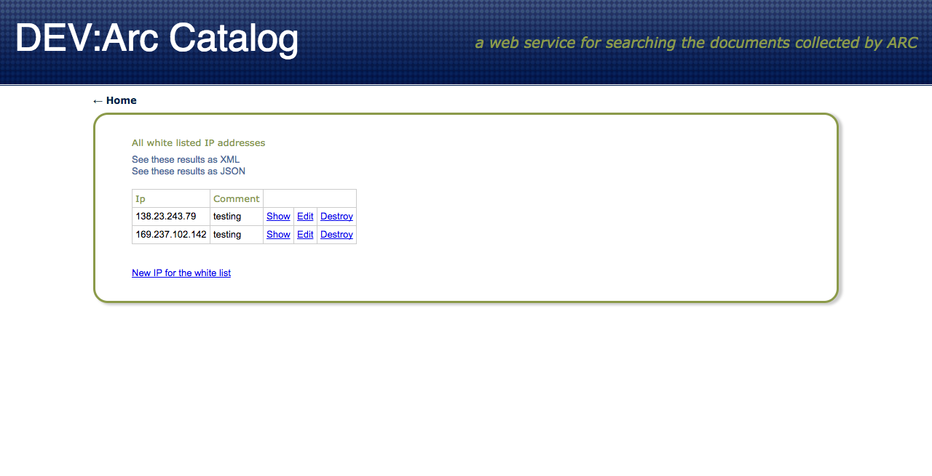
* **Reset Password:** On **Login** page, click **Forgot your password?** Link. 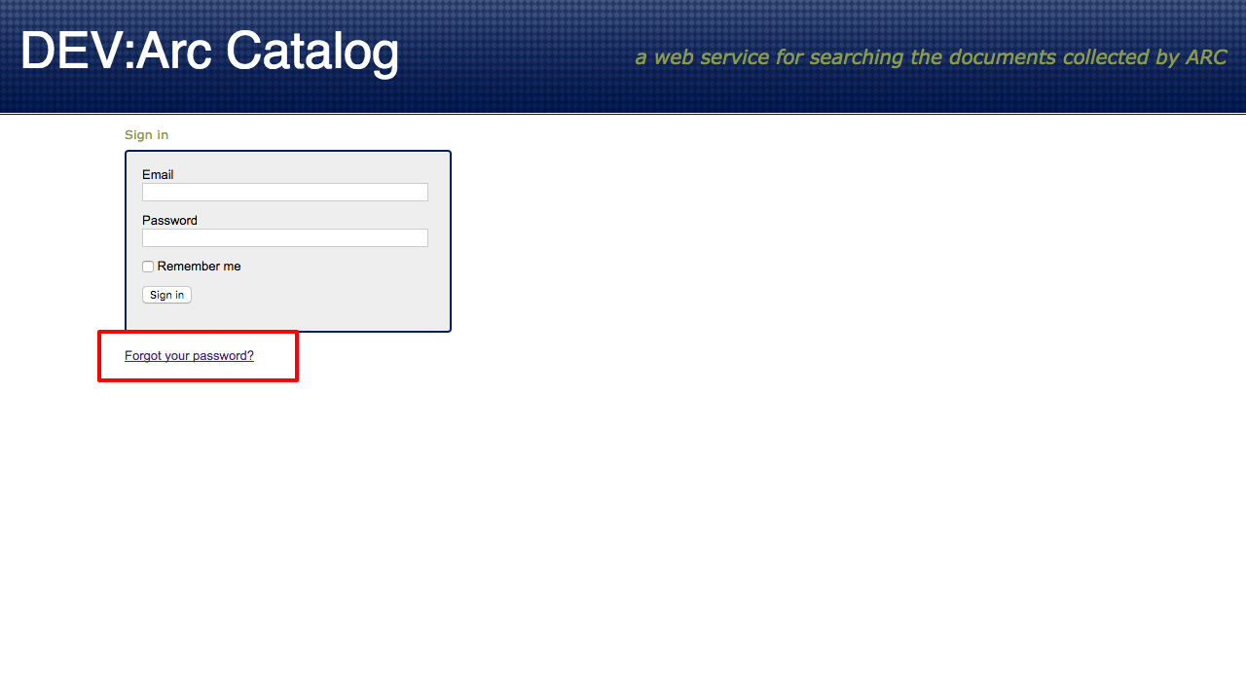
* Enter **Email** and click **Send me reset password instructions** button. An email will be sent to that email address with **a link to reset password.**
* Click **that link (*sample link of format*** [***http://estc21.ucr.edu:3000/users/password/edit?reset_password_token=JZTyKj3Thyo4HisLsETr***](http://estc21.ucr.edu:3000/users/password/edit?reset_password_token=JZTyKj3Thyo4HisLsETr) ***),*** *a new page will be displayed to enter* ***New password & Confirm new password.*** Fill allfields *and* hit**Change me** button. 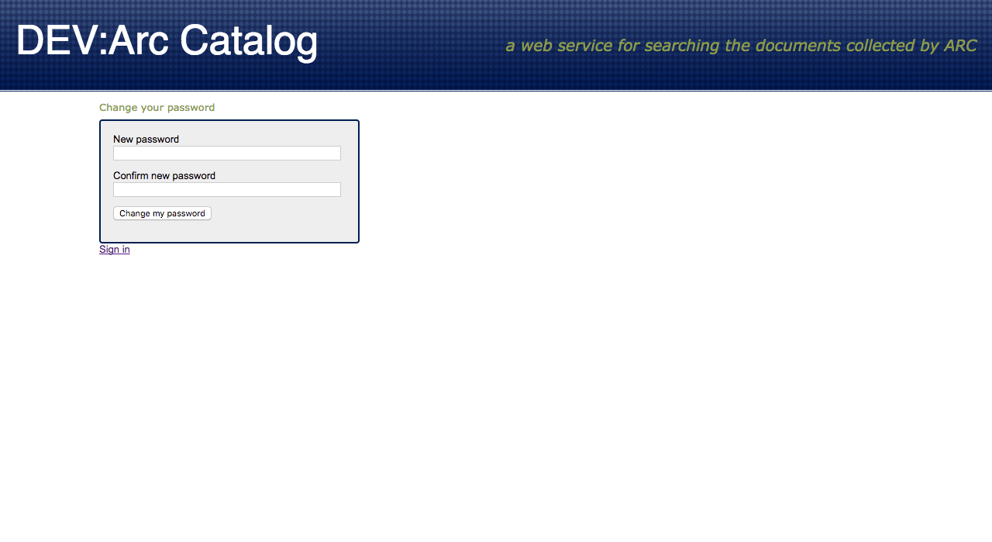
* User will be redirected to the **Sign In** page. Enter **Email & New password** to log into the application.

- - - - - - - - - - - - - - - - - - - - - - - - - - - - - - - - - - - - - - - - - - - - - - - - - - - - - - - - - - - - - - - - - - - - - -